PHISH CARNAGE: A Privacy-First Browser-Based Phishing Detection and Cybersecurity Intelligence System Using Heuristic Analysis and AI-Assisted Threat Detection
Kartik Srivastava, Kaushlendra Shukla, Ashkand Kumar Mishra
Mentor: Mr. M. Abdul Mateen Siddiqui

Abstract
Phishing attacks remain a dominant cybersecurity threat, exploiting user trust through deceptive websites that closely mimic legitimate platforms. These attacks target sensitive information such as login credentials and financial data, leading to identity theft and financial loss. Traditional detection approaches, including blacklist-based and rule-based systems, are limited in identifying zero-day phishing attacks due to their dependence on previously known signatures¹².
This paper presents a privacy-first browser-based phishing detection system that integrates a Chrome extension with a Flask-based backend. The proposed system employs a dual-stage detection mechanism combining heuristic analysis and AI-assisted threat detection. The heuristic stage evaluates URL-based features such as domain length, keyword patterns, and structural anomalies³, while the AI component identifies complex and previously unseen phishing patterns⁵⁷.
Additionally, a conversational AI assistant is incorporated to provide real-time security insights and user guidance. The system emphasizes privacy by performing initial analysis locally within the browser environment. Experimental results demonstrate improved detection accuracy and efficiency, highlighting the effectiveness of hybrid approaches in modern phishing defense.

I. Introduction
The rapid growth of internet technologies has transformed communication, commerce, and digital services. However, this expansion has also increased exposure to cybersecurity threats, among which phishing remains one of the most prevalent and damaging forms of attack⁴.
Phishing attacks exploit human psychology through social engineering techniques, where attackers impersonate trusted entities to deceive users into revealing confidential information. These attacks commonly involve fraudulent emails, malicious links, and visually similar fake websites designed to replicate legitimate platforms⁶. Unlike traditional cyberattacks, phishing does not rely on technical vulnerabilities but rather on manipulating user behaviour, making detection significantly more challenging.
Conventional phishing detection methods, such as blacklist filtering and signature-based approaches, are limited in effectiveness as they rely on previously identified threats. These methods fail to detect newly generated phishing domains and zero-day attacks⁵. Reports indicate that thousands of phishing websites are created daily, emphasizing the need for adaptive and intelligent detection mechanisms¹⁰.
Recent advancements in machine learning and artificial intelligence have enabled the identification of malicious patterns in web data. These approaches analyse URL structures, webpage content, and user interaction patterns to detect anomalies⁷. However, many existing solutions are computationally intensive and operate at the network level, limiting their ability to provide real-time protection at the user level.

II. Literature Review
Phishing detection techniques can be broadly categorized into blacklist-based, heuristic-based, and machine learning-based approaches.
Blacklist-based systems maintain databases of known malicious URLs and block access when a match is detected. While efficient, these systems are reactive and ineffective against newly created phishing websites⁵.
Heuristic-based approaches analyse structural features such as URL length, domain composition, and suspicious keywords. These methods are lightweight and capable of detecting previously unseen threats but may produce false positives when legitimate websites exhibit similar characteristics³.
Machine learning-based approaches utilize classification algorithms such as decision trees, support vector machines, and neural networks to identify phishing patterns⁷. These methods achieve high accuracy when trained on large datasets⁶. Research by Ma et al. demonstrated that learning-based models outperform traditional blacklist systems in detecting malicious URLs¹⁰.
Recent advancements include real-time phishing detection using browser extensions, enabling direct interaction with users and immediate alerts⁸. Additionally, systems such as PhishStorm leverage streaming analytics to improve detection speed and scalability¹².
Despite these advancements, existing systems often lack user interaction features, historical analysis capabilities, and privacy-preserving mechanisms. The proposed system addresses these gaps by integrating browser-based monitoring, backend intelligence, and conversational AI assistance into a unified framework.

III. Methodology
A. Backend Development
The system backend was developed using the Flask framework, serving as the core component responsible for processing URL analysis and managing system data. A dedicated Python virtual environment was configured to resolve dependency issues and ensure system stability.
B. Chrome Extension Development
A Chrome extension was developed to monitor user browsing activity in real time. The extension detects webpage navigation events, extracts URLs, and sends them to the backend server for analysis.
C. Detection Pipeline
The system employs a dual-stage detection mechanism:
- Heuristic Analysis:
Performs rapid evaluation of URL features such as suspicious domains, keyword patterns, and structural anomalies.
- AI-Assisted Detection:
Conducts deeper contextual analysis using generative AI models to identify complex phishing patterns.
D. System Integration
Communication between the extension and backend was achieved using API requests with proper CORS configuration. Real-time alerts are displayed through browser notifications when threats are detected.
E. AI Chatbot Integration
A conversational AI assistant was integrated to provide users with cybersecurity insights and explanations. The chatbot enhances user awareness and supports interaction with the system dashboard.
F. Data Storage and Dashboard
A SQLite database stores analysed URLs, risk scores, and timestamps. The dashboard provides visualization and historical analysis of phishing activity.

IV. Proposed System and Novel Contributions
A. Novel Contributions
The proposed system introduces several key innovations:
- Privacy-First Architecture:
Initial threat analysis is performed locally within the browser, reducing data exposure.
- Hybrid Detection Model:
Combines heuristic filtering with AI-based contextual analysis to improve accuracy and efficiency.
- Conversational Cybersecurity Assistant:
Provides real-time explanations and guidance to users.
- Browser-Level Protection:
Enables immediate threat detection within the user’s browsing environment.
- Threat Intelligence Dashboard:
Supports historical tracking and analysis of phishing activity.
B. System Overview
The system consists of a Chrome extension, backend server, detection engine, AI module, database, and user dashboard.

V. System Architecture
The system follows a multi-layer architecture. The Chrome extension captures URLs and communicates with the Flask backend through secure APIs. The detection engine applies heuristic analysis, followed by AI-assisted processing for deeper evaluation³⁷.
Results are stored in a centralized database, and the dashboard provides visualization and user interaction features.

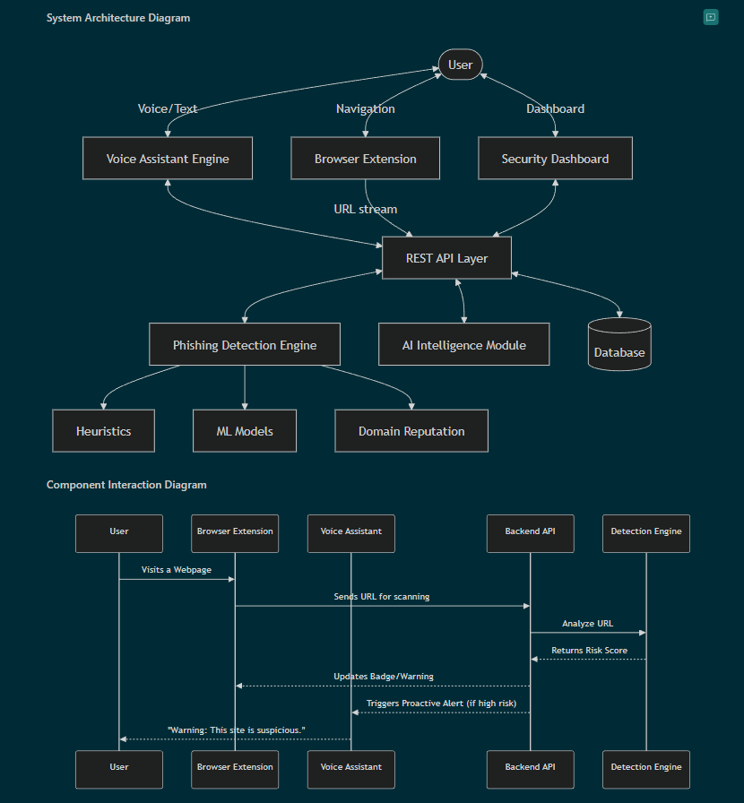
Fig. 1. System Architecture of the Proposed Model
VI. Design and Implementation
The system was developed using a modular approach:
- Flask backend for API processing
- Chrome extension for real-time monitoring
- CORS-enabled integration
- AI chatbot for user assistance
- Dashboard for visualization
This design ensures scalability, maintainability, and efficient performance.

VII. Experimental Results
The system was evaluated using datasets of legitimate and phishing URLs. Results indicate that:
- Heuristic analysis effectively identifies suspicious URL patterns
- AI-assisted detection improves recognition of complex phishing attacks
- Real-time alerts enhance user protection
These findings align with existing research demonstrating the effectiveness of hybrid detection systems⁷¹².

VIII. Limitations
The system has several limitations:
- Dependence on heuristic rules may limit detection of highly sophisticated attacks
- Lack of fully trained machine learning models for predictive classification
- Restriction to browser-based environments
- Potential false positives in certain scenarios
- Scalability challenges with large datasets

IX. Conclusion and Future Work
This research presented a privacy-first browser-based phishing detection system that integrates heuristic and AI-assisted detection techniques. The system provides real-time protection, enhances user awareness, and maintains privacy through localized processing.
Future work includes integrating advanced machine learning models, expanding browser compatibility, and improving detection accuracy against evolving phishing techniques.

References
- A. K. Jain and B. B. Gupta,
“Phishing Detection: Analysis of Visual Similarity Based Approaches,”
Security and Communication Networks, 2017.
- M. Aburrous, M. A. Hossain, K. Dahal, and F. Thabtah,
“Intelligent Phishing Detection System for E-Banking Using Fuzzy Data Mining,”
Expert Systems with Applications, 2010.
- S. Garera, N. Provos, M. Chew, and A. D. Rubin,
“A Framework for Detection and Measurement of Phishing Attacks,”
Proceedings of the ACM Workshop on Recurring Malcode, 2007.
- N. Abdelhamid, A. Ayesh, and F. Thabtah,
“Phishing Detection Based Associative Classification Data Mining,”
Expert Systems with Applications, 2014.
- J. Ma, L. K. Saul, S. Savage, and G. M. Voelker,
“Beyond Blacklists: Learning to Detect Malicious Web Sites from Suspicious URLs,”
Proceedings of the ACM SIGKDD, 2009.
- R. Verma and K. Dyer,
“On the Character of Phishing URLs: Accurate and Robust Statistical Learning Classifiers,”
Proceedings of the ACM Conference on Data and Application Security, 2015.
- W. Zhang, X. Ding, Y. Tang, and Y. Luo,
“Phishing Detection Based on Deep Learning,”
IEEE Access, 2019.
- A. Le, A. Markopoulou, and M. Faloutsos,
“PhishDef: URL Names Say It All,”
IEEE INFOCOM, 2011.
- Google,
“Google Safe Browsing API Documentation,”
Available: https://developers.google.com/safe-browsing
- Anti-Phishing Working Group (APWG),
“Phishing Activity Trends Report,”
Available: https://apwg.org
- Verizon,
“Data Breach Investigations Report (DBIR),”
Available: https://www.verizon.com/business/resources/reports/dbir/
- S. Marchal, J. Francois, R. State, and T. Engel,
“PhishStorm: Detecting Phishing with Streaming Analytics,”
IEEE Transactions on Network and Service Management, 2014.
- D. K. McGrath and M. Gupta,
“Behind Phishing: An Examination of Phisher Modi Operandi,”
USENIX Workshop on Large-Scale Exploits and Emergent Threats, 2008.
- F. Toolan and J. Carthy,
“Feature Selection for Spam and Phishing Detection,”
eCrime Researchers Summit, 2010.

